**Assignment 16.3**

**Problem Statement:**

Execute Session 16 - Assignment 1 (Machine and Sensor data analysis) using Reduce side join and compare which join is faster in normal conditions.

**Input:**

<https://github.com/prateekATacadgild/DatasetsForCognizant/blob/master/Sensor%20data-20161205T052506Z.zip>

**Program:**

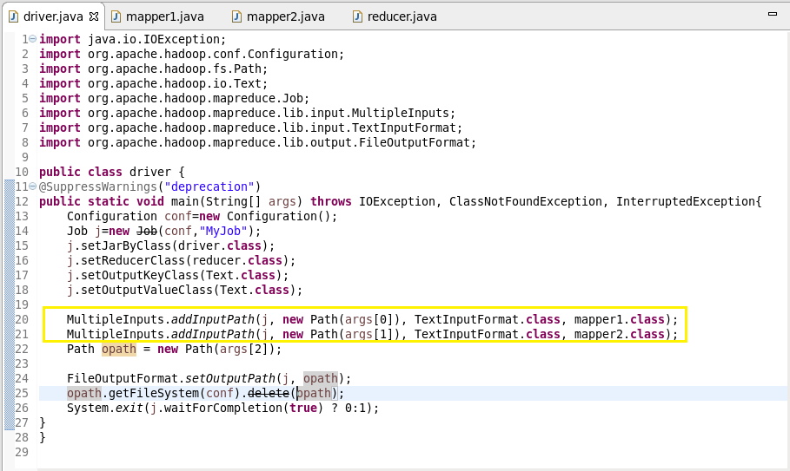

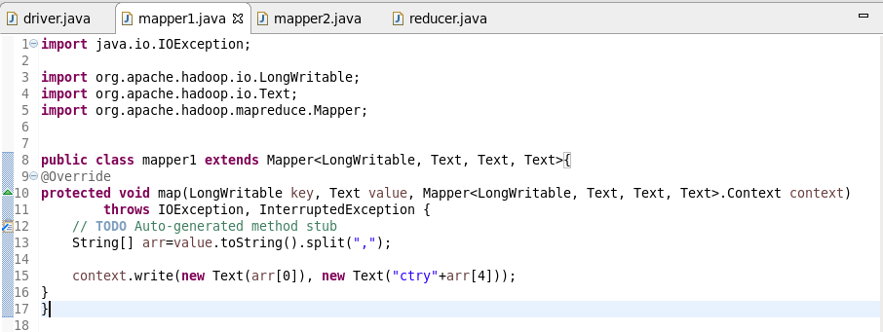

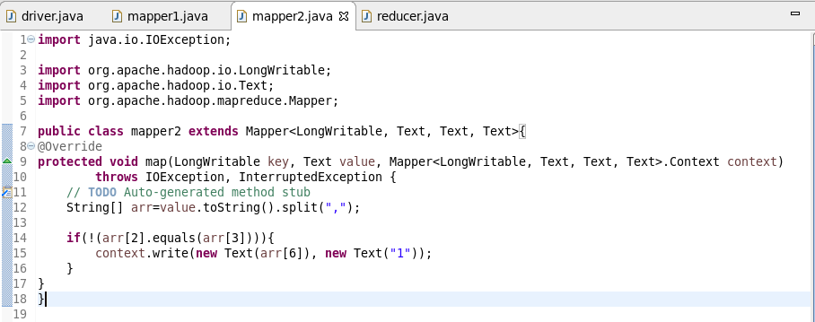

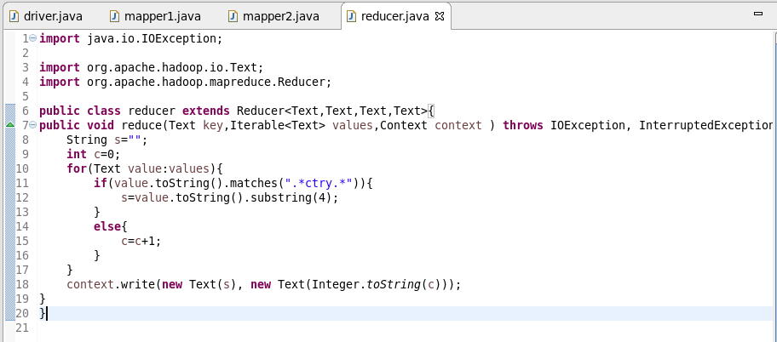

**Output:**

